 | Problem 1 | Problem 2 | Gridded Response
Monday | Solve.  -3x + 9 = -7 – 3x + 16 | What is the length of the hypotenuse of an isosceles right triangle if one of the legs has a length of 14 cm. Round to the nearest tenth is necessary. | Problem 2  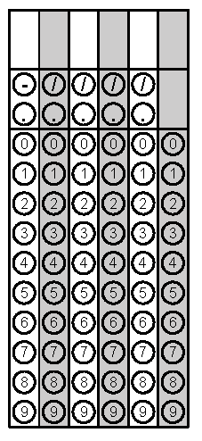
Tuesday | What is the distance between points (-8, -3) and (4, 5) on the coordinate plane? Round to the nearest tenth if necessary. | 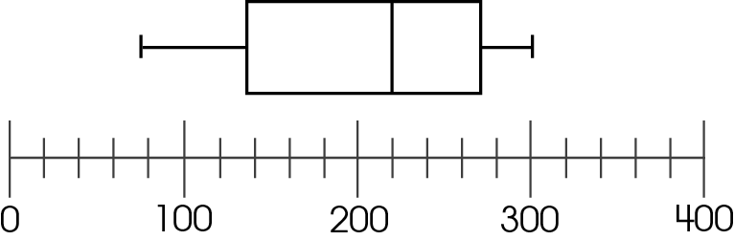  Monthly Milligan Family Text Messages  What is the median number of text messages the members of the Milligan family made this month? | Problem 1
Wednesday | What is the length of the hypotenuse of a right triangle with vertices (-5, 3), (5, 3) and (5, -3)? Round to the nearest tenth if necessary. | Simplify.  $$\frac{16x^{2}y}{24xy^{3}}$$ | Problem 1
Thursday | Simplify.  $${{(x}^{\frac{1}{5}})}^{-5}$$ | The low temperatures for the previous 2 days in Raleigh were 67º and 63º. What would the temperature need to be for the 3rd day so that the average temperature is at least 66º? | Problem 2
Friday | 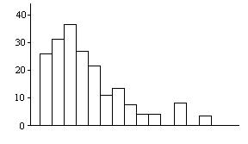  How are the outliers in this data affecting the data/bars of the histogram? | 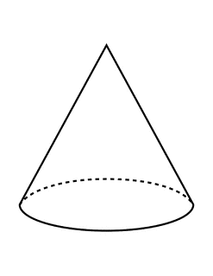  h = 15 cm  r  What would the measurement of the radius be for the above cone if the volume is 141.3 cm³? Round to the nearest tenth if necessary. | Problem 2
Questions adapted from Score21 and SchoolNet

