Bouncing Ball Investigation
The majority of sports in America revolve around some sort of ball. One of the most important aspects of those balls is the elasticity or bounciness of the ball. For example, when a new golf ball is dropped onto a hard surface, it rebounds to about 2/3 of the height it was dropped. The pattern of bounces resembles the declining pattern of a geometric sequence.

Example: Suppose a new gold ball is dropped from a height of 27 feet onto a parking lot and keeps bouncing up and down. Each bounce is 2/3 of the drop height as shown below:

27, 18, 12, 8, . . .

We can take this geometric sequence and put it into a table to keep up with the number of times the golf ball bounces. Complete the rest of the table below and graph on the coordinate plane. Then answer the questions found below the graph.

Bounce Number | 0 | 1 | 2 | 3 | 4 | 5 | 6 | 7 | 8 | 9 | 10
Rebound Height (in feet) | 27 | 18 | 12 | 8
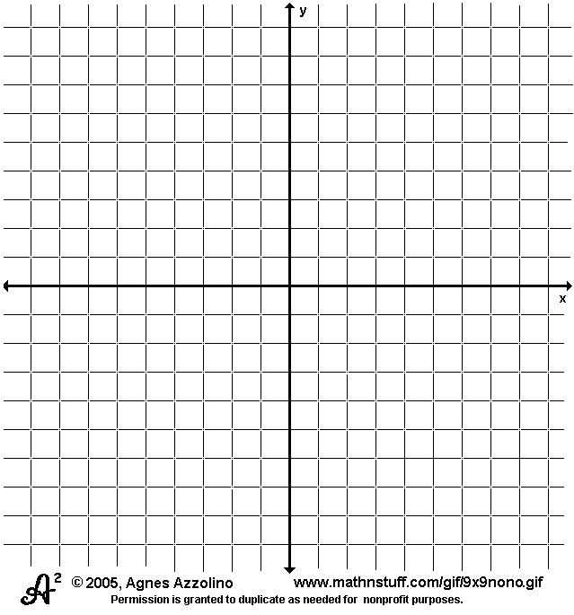
- How does the rebound height change from one bounce to the next? How is that pattern shown by the shape of the data plot?

- What is the initial value of the data?

- What is the common ratio?

- What rule relating NOW and NEXT shows how to calculate the rebound height for any bounce from the height of the preceding bounce?

- What rule beginning with “y = “ show how to calculate the rebound height after any number of bounces?

The table, graph and equations illustrate the concept of exponential decay. Exponential decay occurs when the common ratio r falls between 0 and 1 (0 < r < 1). The graphs of exponential decay problems illustrate a rapid decline of the data.

Your Turn:
How will the data table, plot, and rules for calculating rebound height change if the ball drops first from only 15 feet? Repeat the problem above, this time using a drop height of 15 feet.

Bounce Number | 0 | 1 | 2 | 3 | 4 | 5 | 6 | 7 | 8 | 9 | 10
Rebound Height (in feet) | 15 | 10
- How does the rebound height change from one bounce to the next? How is that pattern shown by the shape of the data plot?

- What rule relating NOW and NEXT shows how to calculate the rebound height for any bounce from the height of the preceding bounce?

- What rule beginning with “y = “ show how to calculate the rebound height after any number of bounces?

Data from actual tests of golf balls will not exactly match the predictions made in the above predictions from the recursive NOW-NEXT and explicit “y =” equations. You will simulate the kind of quality control testing that is done by manufacturing factories by running some experiments in your classroom. Work with a group of three or four people to complete the next problem.

Problem 1: Get a golf ball and tape measure or meter stick from your teacher to use in your group. Decide on a method for measuring the height of successive rebounds after the ball is dropped from a height of at least 8 feet. Collect data on the rebound height for successive bounces of the ball in the table below. Graph the data on the coordinate plane.

Bounce Number | 0 | 1 | 2 | 3 | 4 | 5
Rebound Height (in feet) | 8

- Compare the pattern of your data to that of the predicted data at the top of the first page. Would a rebound height factor other than 2/3 give a better model for your data? Explain.

- Write a rule using NOW-NEXT that relates the rebound height of any bounce of your tested ball to the height of the preceding bounce.

- Write a “y =” rule to predict the rebound height after any bounce.

- How close were your equations?

Problem 2: Repeat the experiment of Problem 1 with some other ball such as a tennis ball or volleyball. Use the table to record the data collected and the coordinate plane to graph the data. Study the data to find a reasonable estimate of the rebound height factor for your new ball. Write NOW-NEXT and “y = “ rules in order to model the rebound height of your ball on successive bounces.

Bounce Number | 0 | 1 | 2 | 3 | 4 | 5
Rebound Height (in feet) | 8

- What is a reasonable rebound height for your data?

- Use your rebound height to write a rule using NOW-NEXT that relates the rebound height of any bounce of your tested ball to the height of the preceding bounce.

- Write a “y =” rule to predict the rebound height after any bounce.

Activity Reflection:
- What similarities do you find with each problem? What differences?

- What do the tables, graphs, and rules in these problems have in common with exponential growth problems that you studied earlier in the unit?

- What is the general NOW-NEXT equation to be used with exponential decay problems?

- What is the general “y = “ equation to be used with exponential decay problems?

Lesson adapted from Core-Plus Mathematics, Glencoe McGraw-Hill, 2008.

