Guided Practice with Geometric Sequences
Determine if the sequence is geometric. If it is, find the common ratio.
- 56, 28, 14, 7,... 2) 64, -48, 36, -27,... 3) 9, 6, 3, 0, -3, -6, …

4) 1000, 100, 10, . . . 5) 8, 2, ½, . . . 6) 18, 6, 2, . . .

Given the initial term and common ratio, write the first 6 terms of the sequence.

7) a₁ = 7, r = 2/3 ___________________________________________________

8) a₁ = 5, r = ½ ___________________________________________________

9) a₁ = 3, r = 3/5 ___________________________________________________

10) a₁ = 3/7, r = ¼ ___________________________________________________

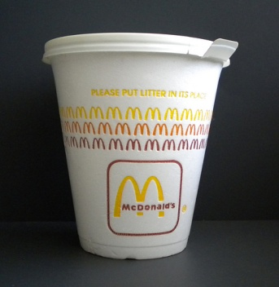
Problem Situation:

A hot vanilla latte from McDonalds is poured into a cup and allowed to cool while you are riding to school. The difference between the latte temperature and room temperature is recorded every minute for 10 minutes. The sequence is found below:

80, 72, 65, 58, 52, 47, 43, 38, 34, 31, 28

11) Is this sequence geometric? If so, what is the approximate common ratio?

12) How is problem similar or different to the Black Rhinoceros problem in the lesson?

