Translation Investigation
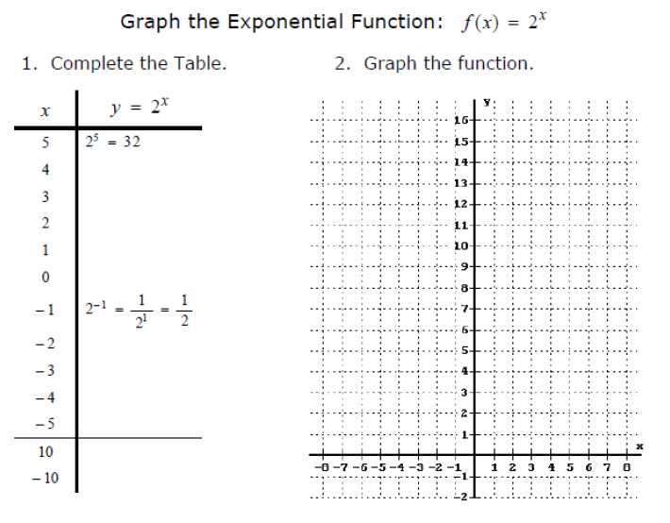

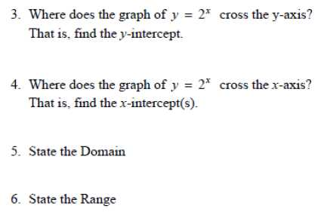

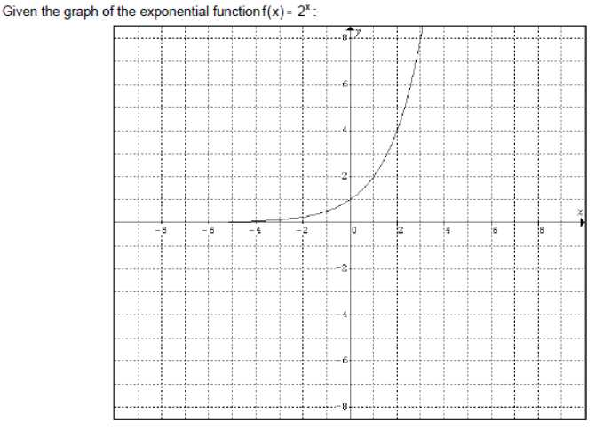

Graph the following functions on the coordinate plane above. After graphing each function, describe the change from the parent function y = 2^{x}.
7. Graph: y = 2^{x} – 5 by making a table. What change occurred from the parent graph y = 2^{x}? Where is the y-intercept now? Where is the x-intercept now?
X-Values | -5 | -4 | -3 | -2 | -1 | 0 | 1 | 2 | 3 | 4 | 5
Y-Values

8. Graph y = 2^{x – 5} by making a table. What change occurred from the parent graph y = 2^{x}? Where is the y-intercept now? Where is the x-intercept now?
X-Values | -5 | -4 | -3 | -2 | -1 | 0 | 1 | 2 | 3 | 4 | 5
Y-Values

9. Graph y = 2^{x – 5} – 4 by making a table. What change occurred from the parent graph y = 2^{x}? Where is the y-intercept now? Where is the x-intercept now?
X-Values | -5 | -4 | -3 | -2 | -1 | 0 | 1 | 2 | 3 | 4 | 5
Y-Values
10. Graph: y = 2^{x} + 3 by making a table. What change occurred from the parent graph y = 2^{x}? Where is the y-intercept now? Where is the x-intercept now?
X-Values | -5 | -4 | -3 | -2 | -1 | 0 | 1 | 2 | 3 | 4 | 5
Y-Values

11. Graph y = 2^{x +3} by making a table. What change occurred from the parent graph y = 2^{x}? Where is the y-intercept now? Where is the x-intercept now?
X-Values | -5 | -4 | -3 | -2 | -1 | 0 | 1 | 2 | 3 | 4 | 5
Y-Values

12. Graph y = 2^{x +3} + 4 by making a table. What change occurred from the parent graph y = 2^{x}? Where is the y-intercept now? Where is the x-intercept now?
X-Values | -5 | -4 | -3 | -2 | -1 | 0 | 1 | 2 | 3 | 4 | 5
Y-Values

13. Describe in your own words how to make a horizontal shift with an exponential function. What does the general exponential function look like?

14. Describe in your own words how to make a vertical shift with an exponential function. What does the general exponential function look like?

15. Describe in your own words how to make both a vertical and horizontal shift with an exponential function. What does the general exponential function look like?

