Scatterplots Review
Positive correlation – when one variable increase the other increases
Negative correlation – when on variable increases the other decreases
No correlation – no relationship between the variables
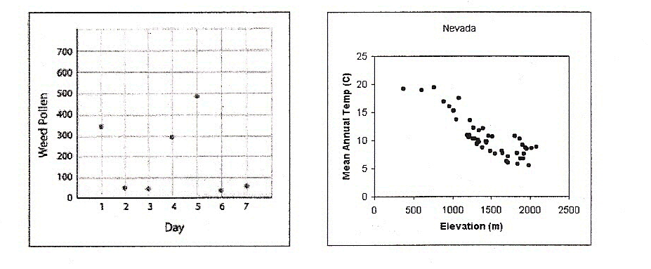
Identify the type of correlation in each scatterplot below.
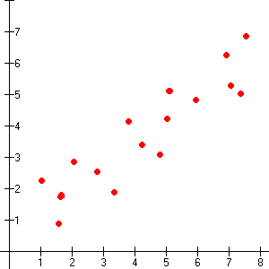

What type of correlation would you expect the following relationships to have?
- The weight of a cat and how much it eats.

- The size of your feet and how many siblings you have.

- The amount of time spent watching TV and a student’s grade in math.

- The scatter plot shows the relationship between games played and tickets won. Which graph below represents the line of best fit?
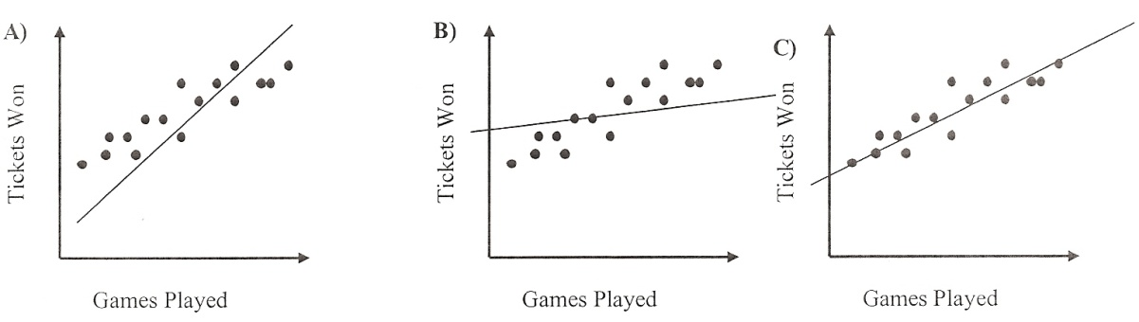

- The scatter plot shows the relationship between hours spent shopping and money. Which graph below represents the line of best fit?
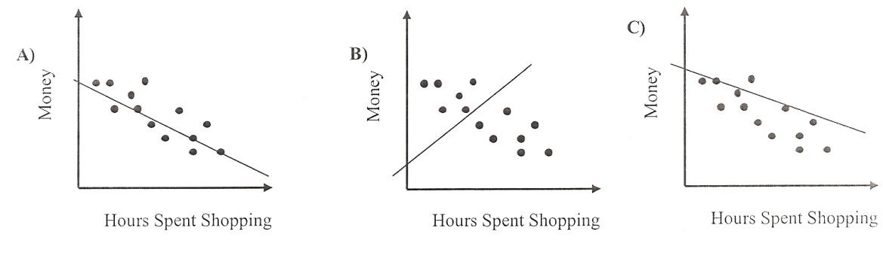

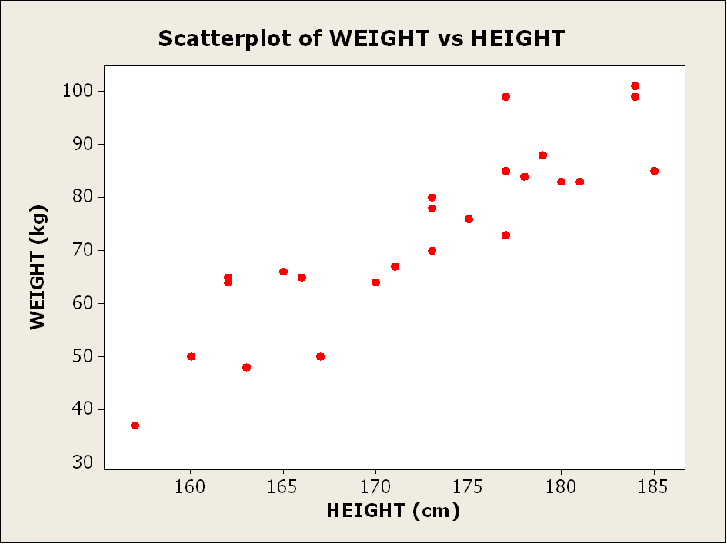
- Look at the graph below comparing height and weight. Draw a line of best fit and answer the following.

- How much would you expect someone who is 172 centimeters to weigh?

- How tall would you expect someone who weighed 85 kg to be?

- Use the data on neighborhood children to write an equation (using your calculator) and then use your equation to answer the questions.
  - Equation __________________________
  - How tall would you expect a two year old to be?
  - How old would you expect a child who is 47 inches tall to be?

Below is a scatterplot showing the relationship between time since noon and money left for a person gambling.
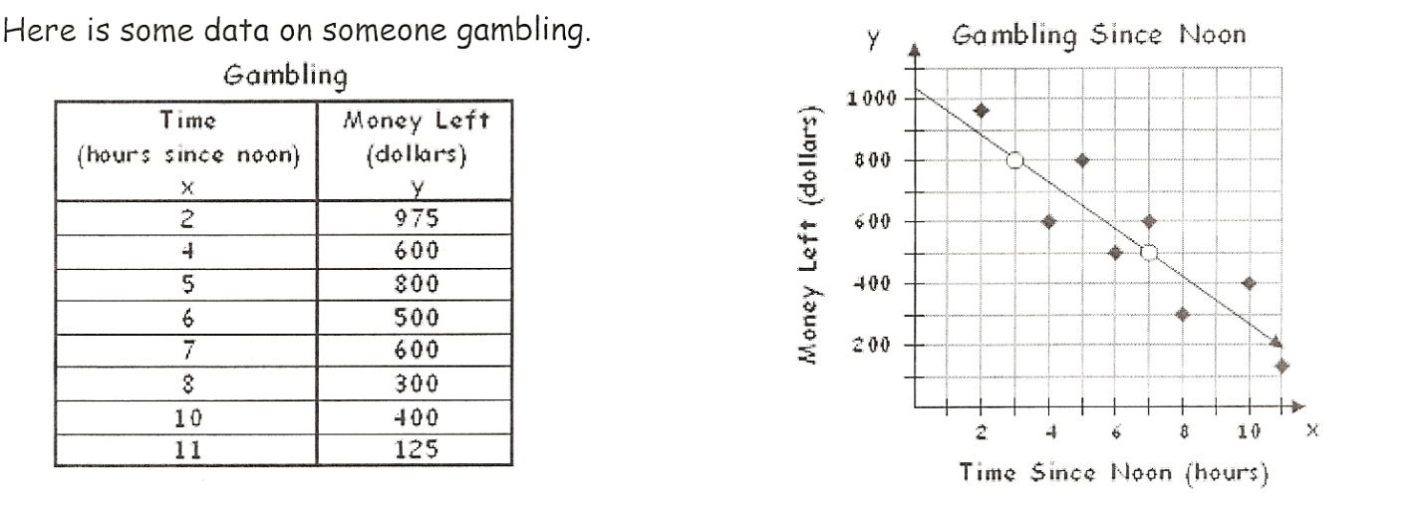
- Use two points that fall on the line to write an equation for your line of best fit.

- What does the y-intercept mean in this problem?

- What does the slope mean in this problem?

- Use your equation to predict when the gambler runs out of money.

- At 10:00pm the gambler says, “Hey, I’m on a roll! I’ve been making money for the last two hours.” Is this true? How would you advise the gambler?

- Confirm your answer by seeing how much the gambler will have left after 14 hours of gambling.

- What if the gambler kept going for 24 hours? What would be the dollar value? What does this mean in the context of this problem?

