Use the following example and screenshots to learn how to graph scatterplots and line of best fit.

To make sure that everyone begins on the same page please reset the memory on your calculator.

2nd |  | + |  | 7 |  | 1 |  | 2

Example: Plot the data and calculate the line of best fit.
X | Y
2 | 4
7 | 13
3 | 7
4 | 8
6 | 11
1 | 2
9 | 17
5 | 10

Creating a List

Edit a list:
STAT
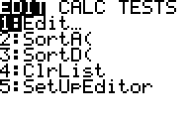

1
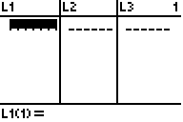
L1 : x-values
L2: y-values

Type in each x-value and press enter after each value until all values have been entered.
Arrow over to L2 and enter all the y-values

Plotting a Scatterplot

2nd
Y = (STATPLOT)
1

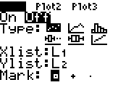

Move the cursor to highlight “On” and press , this turns Plot 1 on.
ENTER
The type defaults to scatterplot and the xlist and ylist defaults to L1 and L2.
You do not need to make any other adjustments.

You can also turn Plot 1 ON
Y =
▲
ENTER

ZoomStat
ZOOM
9
This will automatically adjust the window to fit the data.
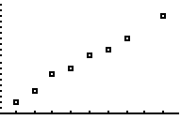

What kind of correlation is this data?
 | Positive |  |  | Negative |  |  | No Correlation

Calculating Line of Best Fit

DiagnosticOn
2nd
0
▼
ENTER
You will see “Done”. This will allow us to see how strong the correlation is. Close to 1, strong positive correlation, close to -1, strong negative correlation.
ENTER

CALC LinReg (ax + b)
STAT
►
4
2nd
1 (L1)
,
2nd
2 (L2)
ENTER
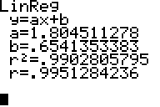
The equation of the line is approximately y = 1.8x + 0.65.
The r² value of 0.99 indicates a strong positive correlation.

Putting the equation into Y=
This will be a repeat of some of the steps from “Calculating Line of Best Fit”
CALC LinReg (ax + b)
STAT
►
4
2nd
1 (L1)
,
2nd
2 (L2)
,

Y-VARS
VARS
►
1
1
ENTER
The screen will look the same, but go to
Y =
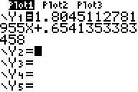
“Plot 1” being highlighted indicates that Plot 1 is on. The steps above put the equation into Y₁ instead of rounded.
GRAPH

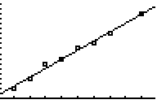
You can see your data plotted, as well as the line of best fit.

Using the TABLE and TBLSET

2nd
GRAPH (TABLE)
TABLE allows you to observe the y-values of the function you are working with without having to do all the calculations by hand.

While in the table you can scroll up or down through the x-values. The table defaults to start at 0 and use increments of 1.
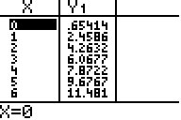

You have the ability to adjust the settings of your table through
2nd
WINDOW (TBLSET)
For example, if you do not want to scroll to a certain number, you can set the window to start at a certain x-value.
If I ask, using your line of best fit, what would the y-value be if the x-value is 15? You can substitute 15 for x and simplify, you can also use the table. You can scroll or you can change where the table starts.

Go to and adjust the TblStart = 15
2nd
WINDOW (TBLSET)
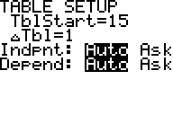
ΔTbl allows you to change how much the x-values changes by.

Misc.
Clearing lists

STAT
1
▲
CLEAR
ENTER

OR
# of list you would like cleared, you may clear multiple lists using a comma.
STAT
4
2nd

