Name
Class
Date

Scatter Plots and Trend Lines
5-7
ELL Support

Concept List

causal relationship correlation coefficient extrapolation
interpolation line of best fit negative correlation
no correlation positive correlation trend line

Choose the concept from the list above that best represents the item in each box.

1. LinReg (ax + b) | 2.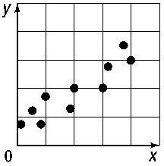 | 3.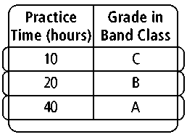
4.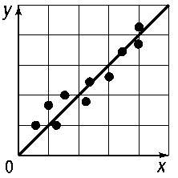 | 5.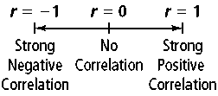 | 6.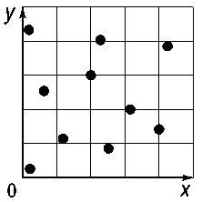
7.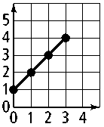  Estimate the value for y when x = 3.5. | 8.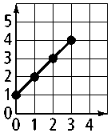  Estimate the value for y when x = 1.5. | 9.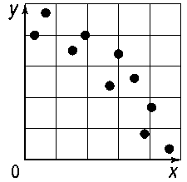
Prentice Hall Algebra 1 • Teaching Resources
Copyright © by Pearson Education, Inc., or its affiliates. All Rights Reserved.
61

