**Scatterplot and Line of Best Fit Notes**

______________________: a graph that relates two sets of data, where the x-coordinate is the __________________________ variable and the y-coordinate is the __________________________ variable

Types of Correlations:

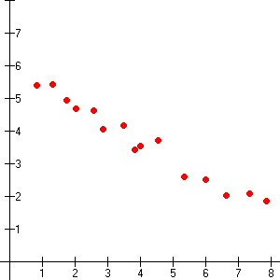 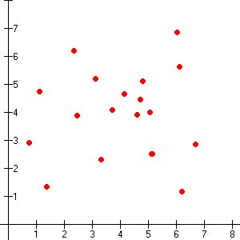 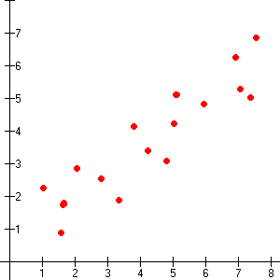

_________________________ _________________________ _________________________

The trend line that shows the relationship between two sets of data most accurately is called the ______________________. A graphing calculator computes the equation of a line of best fit using a method called ____________________________.

The graphing calculator also gives you the _________________________________ r, which tells you how closely the equation models the data.

detail vis d link

When the data points cluster around a line, there is a strong correlation between the line and the data. So the nearer r is to 1 or −1, the more closely the data cluster around the line of best fit.

**Line of Best Fit Examples**

Draw the line of best fit

  

**Draw the line of best and write the equation of the line (slope-intercept form) – Eyeball Method**



**Graph 3**

**Graph 2**

**Graph 1**

a.) Draw the line of best fit, showing the general trend of the line

b.) Choose two points on the line of best fit, the points may not necessarily be a data point

c.) Find the slope using those two points

d.) Use the slope and one of the points to substitute into y = mx + b

e.) Solve for b.

f.) Write the equation of the line in slope-intercept form by substituting m and b into y = mx + b

|  |  |  |
| --- | --- | --- |
| **Graph 1** | **Graph 2** | **Graph 3** |
| b.) | b.) | b.) |
| c.) | c.) | c.) |
| d.) | d.) | d.) |
| e.) | e.) | e.) |
| f.) | f.) | f.) |

**Draw the line of best and write the equation of the line (slope-intercept form) – Xmean, Ymean Method**



**Graph 3**

**Graph 2**

**Graph 1**

|  |  |
| --- | --- |
| X | Y |
| 2 | 2 |
| 3 | 4 |
| 4 | 4 |
| 5 | 6 |
| 5 | 7 |
| 6 | 5 |
| 7 | 8 |

|  |  |
| --- | --- |
| X | Y |
| 1 | 8 |
| 2 | 7 |
| 3 | 5 |
| 5 | 6 |
| 6 | 3 |
| 7 | 4 |
| 9 | 2 |

|  |  |
| --- | --- |
| X | Y |
| -4 | -3 |
| -3 | -1 |
| -1 | -2 |
| 0 | 1 |
| 2 | 1 |
| 2 | 2 |
| 3 | 4 |

a.) Calculate the Xmean, Ymean point (mark with an X on the graph)

b.) Draw the line of best fit, showing the general trend of the line, making sure the line passes through Xmean, Ymean point

c.) Choose one point on the line of best fit, the points may not necessarily be a data point, and the Xmean, Ymean

d.) Find the slope using those two points

e.) Use the slope and one of the points to substitute into y = mx + b

f.) Solve for b.

g.) Write the equation of the line in slope-intercept form by substituting m and b into y = mx + b

|  |  |  |
| --- | --- | --- |
| **Graph 1** | **Graph 2** | **Graph 3** |
| a.) | a.) | a.) |
| c.) | c.) | c.) |
| d.) | d.) | d.) |
| e.) | e.) | e.) |
| f.) | f.) | f.) |
| g.) | g.) | g.) |

**Draw the line of best and write the equation of the line (slope-intercept form) – Q-Points Method**



**Graph 3**

**Graph 2**

**Graph 1**

|  |  |
| --- | --- |
| X | Y |
| 2 | 2 |
| 3 | 4 |
| 4 | 4 |
| 5 | 6 |
| 5 | 7 |
| 6 | 5 |
| 7 | 8 |

|  |  |
| --- | --- |
| X | Y |
| 1 | 8 |
| 2 | 7 |
| 3 | 5 |
| 5 | 6 |
| 6 | 3 |
| 7 | 4 |
| 9 | 2 |

|  |  |
| --- | --- |
| X | Y |
| -4 | -3 |
| -3 | -1 |
| -1 | -2 |
| 0 | 1 |
| 2 | 1 |
| 2 | 2 |
| 3 | 4 |



a.) Calculate the 1st and 3rd Quartiles of the x- and y-coordinates

**(Q1, Q3)**

**(Q1, Q1)**

**(Q3, Q1)**

**(Q3, Q3)**

b.) Use the 1st and 3rd Quartiles to write **Q-Points**

**Positive Correlation**

(Q1 of x-coordinates, Q1 of y-coordinates)

(Q3 of x-coordinates, Q3 of y-coordinates)

**Negative Correlation**

(Q1 of x-coordinates, Q3 of y-coordinates)

(Q3 of x-coordinates, Q1 of y-coordinates)

c.) Mark appropriate Q-Points with X’s on the graph

d.) Draw the line of best fit passing through the Q-Points

e.) Find the slope using Q-Points

f.) Use the slope and one of the Q-Points to substitute into y = mx + b

g.) Solve for b.

h.) Write the equation of the line in slope-intercept form by substituting m and b into y = mx + b

|  |  |  |  |  |  |  |  |  |
| --- | --- | --- | --- | --- | --- | --- | --- | --- |
| **Graph 1** | | | **Graph 2** | | | **Graph 3** | | |
| a.) | Q1 (x) | Q3 (x) | a.) | Q1 (x) | Q3 (x) | a.) | Q1 (x) | Q3 (x) |
| Q1 (y) | Q3 (y) | Q1 (y) | Q3 (y) | Q1 (y) | Q3 (y) |
| b.) | | | b.) | | | b.) | | |
| e.) | | | e.) | | | e.) | | |
| f.) | | | f.) | | | f.) | | |
| g.) | | | g.) | | | g.) | | |
| h.) | | | h.) | | | h.) | | |