Making Connections - Parallel Lines and the Triangle Sum Theorem
How can I show that the sum of the interior angles of a triangle is equal to 180° using what I know about the relationships between the angles of parallel lines cut by a transversal?
Use the following figure to answer the questions that follow.

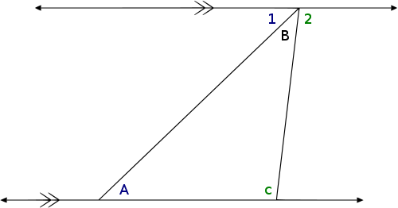

- Knowing that angle 1, angle B and angle 2 form a straight line, what is their sum?

- What kind of angles are angle C and angle 2? What is their relationship?

- What kind of angles are angle A and angle 1? What is their relationship?

- Based on your answers to questions 1 – 3, how do you know that the sum of angle A, angle B, and angle C is 180°?

Making Connections - Parallel Lines and the Triangle Sum Theorem (answers)
How can I show that the sum of the interior angles of a triangle is equal to 180° using what I know about the relationships between the angles of parallel lines cut by a transversal?
Use the following figure to answer the questions that follow.

- Knowing that angle 1, angle B and angle 2 form a straight line, what is their sum?

A straight line measures 180°, therefore the sum of angle 1, B, and 2 is 180°

- What kind of angles are angle C and angle 2? What is their relationship?
Angle C and 2 are alternate interior angles. Because there are parallel lines being cut by a transversal angle C and 2 are congruent.
- What kind of angles are angle A and angle 1? What is their relationship?

Angle A and 1 are alternate interior angles. Because there are parallel lines being cut by a transversal angle A and 1 are congruent.

- Based on your answers to questions 1 – 3, how do you know that the sum of the angle A, angle B, and angle C is 180°?
Answers will vary – Example: I know that the sum of angles A, B, and C is 180° because the sum of angle 1, B and 2 is 180° and angle 1 is congruent to angle A and angle 2 is congruent to angle C.

