Graphing and Writing Equations of Lines Using Intercepts

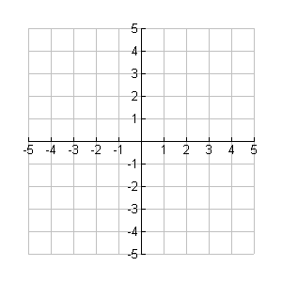

* Graph the line whose

x-intercept is 3 and

**y-intercept is –1.**

* Write the equation of this line.

For each of the following problems, graph the line given the intercepts then write the equation of the line.

1. x-intercept: -2 2. x-intercept: 1 3. x-intercept: -4

y-intercept: -4 y-intercept: 3 y-intercept: 1



Equation __________ Equation ____________ Equation ____________

Standard Form and Intercepts

Another Option for Graphing Linear Equations!!

Standard Form –

Standard forms give you another option for graphing equations. Instead of transforming the equation to slope-intercept form (y=mx+b), you can use Standard Form to solve for the x- and y-intercepts, then graph.

Example 1:

Find the x-intercept and y-intercept of the line 2x + 3y = 6. Use the intercepts to graph the equation.

Find the x-intercept:

Find the y-intercept:

You Try:

Find the x-intercept and y-intercept of the line x – y = -3. Use the intercepts to graph the equation.

Find the x-intercept:

Find the y-intercept: