 | Problem 1 | Problem 2 | Gridded Response
Monday | Graph the line $y=-\frac{2}{3}x+5.$ | What is the sum of all the integers between $-\sqrt{20}$and $\sqrt{20}?$ | Problem 2  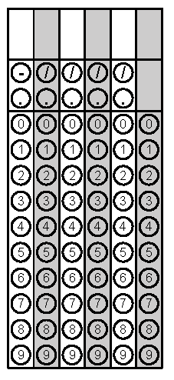
Tuesday | Find the value of x.  $$\frac{-8x-4}{6}=-12$$ | Circle the non-linear functions.  $$-3x+4y=12$$  $$3x\left(x-4\right)=12$$  $$x^{2}+y^{2}=16$$  $$6-2x=y$$ | Problem 1
Wednesday | Find the value of x and y. | Martin is drawing the path of a boat on a coordinate plane, where 1 unit is equal to 1 kilometer. The boat started from (2,4) and headed northeast until it reached (5, 8). The boat then turned and headed northwest until it reached (-1, 16). About how many more kilometers did the boat travel than if it would have traveled straight to (-1, 16) from its starting point? To the nearest tenth. | Problem 2
Thursday | Write the equation of the line that passes through the points  (-5, 7) and (-2, 13)? | Leah calculated the slope of a line to be $\frac{-1}{3}.$The line passes through (1, 7) and (x, 4). Find the value of x. | Problem 2
Friday | The equation, y = 3.5x, represents the number of books, y that Amanda read in x, months. The number of books Hunter read in a month is given in the table below.  Who read more books?  How many more books did this person read per month? | The table below is a linear function. What is the value of y, when x = 0? | Problem 2
Questions adapted from Score21 and SchoolNet

