 | Problem 1 | Problem 2 | Gridded Response
Monday | Simplify  $$\frac{{10}^{-3}∙{10}^{-5}}{{10}^{-7}}$$ | Santana missed 3 out of 11 questions on her science test. What percentage did she answer correctly on the test? Write your answer as a repeating decimal. | Problem 1  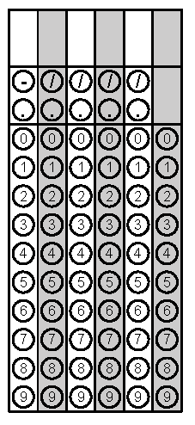
Tuesday | In 2013, the approximate population of the United States was 3.2 x 10⁸ people. Also, there were about 1.3 x 10⁸ households in the United States. Rounding to the nearest hundredth, about how many people live in each household? | Austin is painting a square mural on the wall. The area of the mural is 60 square inches. Rounding to the nearest hundredth inches, about how long is each side of the mural? | Problem 2
Wednesday | Which point best represents the $\sqrt{30?}$ | John grew $1.\overline{28}$inches in June and $0.\overline{7}$ inches in July. How much more did John grow in June than July? | Problem 2
Thursday | The perimeter of a stop sign is 96 inches. Each side of the stop sign is 2x + 4 inches. Find the value of x. | Simplify  $${\left(3a^{5}b^{-2}\right)}^{0}∙3a^{4}∙{\left(2a^{4}\right)}^{2}$$ | Problem 1
Friday | Tina has two rectangular playpens to keep her new pet dogs. The first rectangle has a width of 6 feet and a length of x - 4 feet. The second rectangle has a width of 8 feet and a length of  x + 2 feet. What is the sum of the two perimeters? | The product of six and a number increased by three is the same as fifteen less than twelve times the same number. What is the number? | Problem 2
http://quickfacts.census.gov/qfd/states/00000.html
Questions adapted from Score21 and SchoolNet

