 | Problem 1 | Problem 2 | Gridded Response
Wednesday | Circle the equations.  3x + 5 = 10  3x + 5y  3x > 7  -2(x+ 7) = 27 | Approximate $\sqrt{50}$to the nearest tenth. | Problem 2  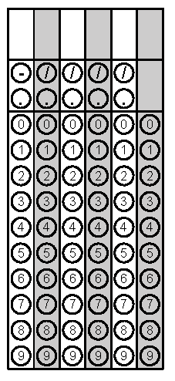
Thursday | What is the value of  $$\frac{9}{11}∙0.\overline{22}$$ | The distance from the Sun to Mercury is 3.5 x 10⁷ miles. There are 48 million miles between Mercury and Earth. How far is Earth from the Sun? | Problem 1
Friday | List the following numbers in order from least to greatest.  $-\sqrt{15}$ $-4.5$ $-\frac{12}{3}$ | Convert $\frac{7}{8}$ to a decimal. | Problem 2

