 | Problem 1 | Problem 2 | Gridded Response
Wednesday | Simplify:  $\sqrt[3]{64}$ + $\sqrt{225}$ | Use the distributive property to simplify the expression.  -4(2x-7y) + 8y | Problem 1  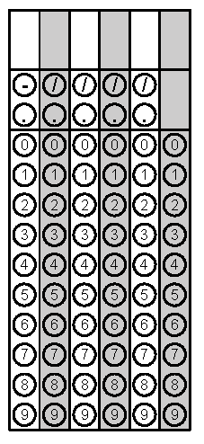
Thursday | Kim is ordering a pizza online. She will randomly select one crust type, sauce, and topping.  Crust Type Sauce Toppings  Thin Red Sauce Cheese  Hand-Tossed White Sauce Pepperoni  Thick Sausage  What is the probably she will select thin crust, red sauce, and pepperoni? | Based on the table, write an equation to represent the dollars earned, d, for any amount of hours worked, w.  Equation _____________ | Problem 1
Friday | Solve the equation:  -2x + 5 = 25 | Angles X and Y are supplementary. Angle X measures 5x-6. Angle Y measures 141 degrees.  What is the value of x? | Problem 1
Questions adapted from Score21 and SchoolNet

