Boxplots, Outliers, and IQR Notes

- Listed below are the quality rating values for regular peanut butter:

11, 23, 23, 26, 29, 31, 31, 33, 34, 34, 35, 40, 40, 43, 45, 46, 49, 54, 54, 60, 76, 83, 83

- Find the five number summary for the data.

______________ ______________ ______________ ______________ ______________
Minimum 1st Quartile Median 3rd Quartile Maximum

- Construct a box plot showing the distribution of quality ratings for regular peanut butter.

0 10 20 30 40 50 60 70 80 90 100

- What is the IQR?

- Do you think there are any outliers? Explain your thoughts.

- Use the steps below to find the outliers, if any.

Steps for Finding Outliers (1.5 IQR Rule)

- Calculate the IQR ________
- Multiply the IQR by 1.5 ________
- Add this value to Q3. ________
(Any value above is considered an outlier)
- Subtract the Value from Q1. ________
(Any value below is considered and outlier)

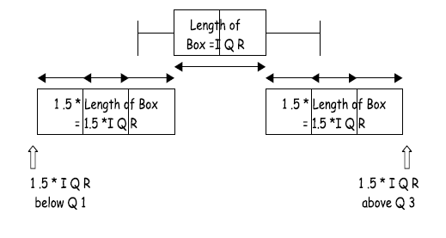
Interpreting Measures of Spread
- Range: Max – Min; spread of the entire data set – sensitive to outliers
- IQR: Q₃ – Q₁; spread of the middle 50% of the data – not sensitive to outliers
- Standard Deviation: the typical amount that a data value will vary from the mean – sensitive to outliers

How do you decide whether to use the mean and standard deviation or the median and IQR to summarize the data numerically?

