**Name:_____________________________________ Parent Signature ______________________________**

**Unit 9 Functions Study Guide**

**Directions: Fill in the definition with the missing word.**

1. Linear: a graph that forms a ______________ and therefore depicts a constant rate of change.
2. Linear relationship: A relationship used to describe the relationship between a variable and a

______________.

1. A ______________ is a relation that assigns exactly ______________ value in the range to each value in the domain.
2. A function ______________ is a specific set of values for a given function.
3. The resulting number for a given input is called the ______________.
4. A relation is a set of ______________ pairs.
5. The ratio of a vertical rise that corresponds to a horizontal run is called the ______________ of ______________.

**8. Complete the table and graph the function.**

|  |  |  |
| --- | --- | --- |
| x (input) | y(output) | Ordered pair (x,y) |
| -2 |  |  |
| 0 |  |  |
| 3 |  |  |
| 7 |  |  |



Is this a function? ­­ YES or NO

Explain your reasoning:

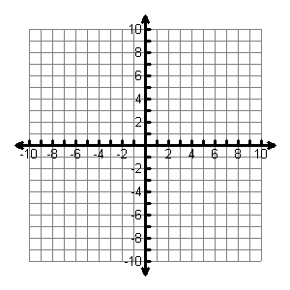

Is this graph linear or non- linear?

9. Describe the graph of the function between ***x* = 0 and *x* = 3**? Use words such as increasing, decreasing, linear, or non-linear.

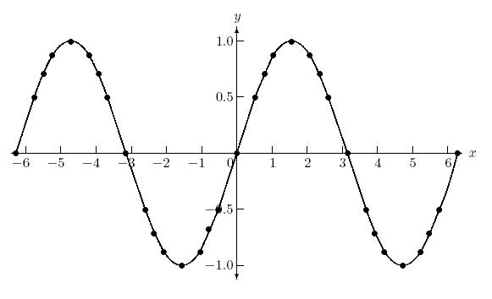

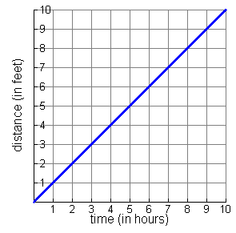10. The three different linear functions below are represented in three different ways, as shown. Find the rate of change for each graph.

|  |  |
| --- | --- |
| **x** | **y** |
| **-3** | **-9** |
| **3** | **3** |
| **6** | **9** |

**I . y = 2x + 1 II.**

**III.**

**Rate of Change _______ Rate of Change _______ Rate of Change _______**

Which function has the greatest rate of change? ________________________________________________

Does any pair of functions have the same rate of change? **Justify your answer. ________________________**

11 . Of the four linear functions represented below, which has the greatest rate of change?_________________

A. Simon texts ten times per minute. **Rate of Change _______**

B. y = 12x **Rate of Change _______**

|  |  |
| --- | --- |
| x | y |
| 0 | 0 |
| 2 | 22 |
| 4 | 44 |

C. **Rate of Change _______**

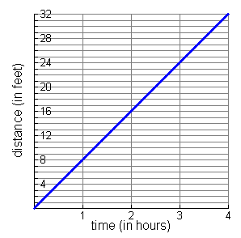D. **Rate of Change _______**

Explain how you knew which had the greatest rate of change. _______________________________________

__________________________________________________________________________________________

__________________________________________________________________________________________