 | Problem 1 | Problem 2 | Gridded Response
Monday | Write in Exponential Form.  $${(\sqrt[3]{3a})}^{4}$$ | What is the value of  $\frac{9}{11}∙0.\overline{22}$? | Problem 2  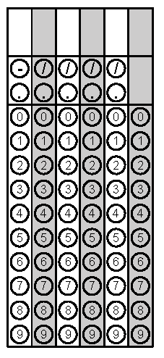
Tuesday | Four more than twice Mark’s age is the same as his age ten years from now. How old is Mark? | Simplify.  5(3a + b) – 2(3a -2b) | Problem 1
Wednesday | Milly goes to the fair where it costs $10 to get in and $.60 a ride. If she can spend at most $30, what is the greatest number of rides she can ride at the fair? | Solve for r.  $$V= \frac{1}{3}πr^{2}h$$ | Problem 1
Thursday | Solve for b.  $$a^{2}+ b^{2}= c^{2}$$ | Evaluate.  $${ (25)}^{\frac{1}{2}}$$ | Problem 2
Friday | Solve.  7s – 4(4s-14) = -43 | The sum of three consecutive even integers is negative forty-eight. What is the greatest integer? | Problem 2
Questions adapted from Score21 and SchoolNet

