**Tying It All Together**

|  |  |
| --- | --- |
| **Number of hops** | **Distance covered (ft)** |
| **2** | **10** |
| **4** | **20** |
| **6** | **30** |
| **8** | **40** |
| **10** | **50** |

The data in the table below is taken from a jackrabbit’s number of hops and distance covered.

1. **Plot the jackrabbit’s data on the graph provided below.**

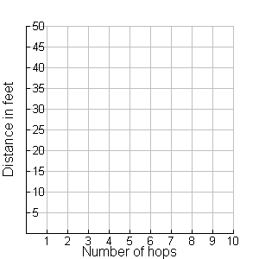



1. **Does this graph go through the origin?**

**Why does this make sense for this scenario?**

1. **How would the graph look different if the jackrabbit hopped a shorter distance each hop?**
2. **What equation could be written to represent this data?**
3. **What does the *coefficient* represent in your equation?**
4. **What do you notice about the ratio of distance to hops?**