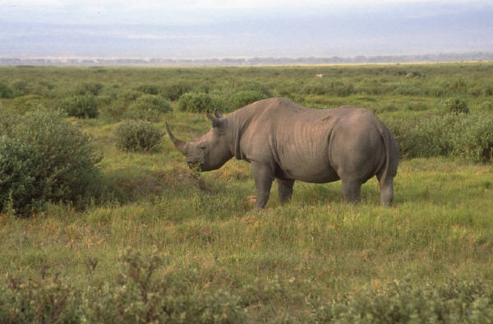
Declining Geometric Sequence Activity
Arithmetic Sequence Common Difference
Geometric Sequence Common Ratio
Initial Term

Problem Situation:
The African Black Rhinoceros is the second largest of all land mammals and has been around for 40 million years. Prior to the 19th century, over 1,000,000 of the species roamed the plains of Africa; however, the number has been reduced by hunting and loss of natural habitat. The following sequence shows the population from the 1970s to early 1090s.
650,000; 195,000; 58,500; 17,550; 23,000

- What are the next three terms of the sequence?

- How did you predict the number of rhinoceros for the 6th, 7th, and 8th terms?

- What is the initial term of the sequence?

- What is the pattern of change?

- Do you think the sequence above is an arithmetic sequence? Why or why not?

- Do you think the sequence is a growing sequence? Why or why not?

Remember that an arithmetic sequence goes from one term to the next by always adding (or subtracting) the same value, called the common difference. A geometric sequence goes from one term to the next by always multiplying (or dividing) by the same value, called the common ratio. In growing sequences the initial value and all subsequent values are multiplied by the common ratio. In declining sequences the initial value and all subsequent values are divided by the common ratio.
The number multiplied (or divided) at each stage of a geometric sequence is called the common ratio r, because if you divide successive terms, you'll always get this common value. So, let’s determine the common ratio r of the Black Rhinoceros Sequence.

650,000; 195,000; 58,500; 17,550; 5,265
195,000/650,000 = 3/10 or 0.3
58,500/195,000 = 3/10 or 0.3
17,550/58,500 = 3/10 or 0.3
5,265/17,550 = 3/10 or 0.3
The common ratio of the Black Rhinoceros is r = 3/10 or 0.3 and the initial term is 650,000. Recall that the initial term is simply the first term of the sequence. In our example, the initial term is 650,000. Let’s now find the initial term and the common ratio of other geometric sequences.

Example 1: 4, 8/3, 16/9, 32/27, 64/81 . . .
Initial term:________ Common ratio:________
Example 2: 6, -3, 3/2, -3/4 . . .
Initial term:________ Common ratio:________
Now it is time for you to determine if the following sequences are arithmetic or geometric. If the sequences are geometric, then determine if they are growing or declining. On the next page, you will find some problems to help you practice your skills on sequences.

