**C:\Documents and Settings\kkelly3\Local Settings\Temporary Internet Files\Content.IE5\2D2NIQRL\MC900432423[1].wmfGuided Practice: More Bacteria**

The bacteria E. coli often causes illness among people who eat the infected food. Suppose a single E. coli bacterium in a batch of ground beef begins doubling every 10 minutes.

1. Complete the table below to determine how many bacteria there will be after 10, 20, 30, 40, and 50 minutes have elapsed (assuming no bacteria die).

|  |  |  |  |  |  |
| --- | --- | --- | --- | --- | --- |
| **10-min Period** | 1 | 2 | 3 | 4 | 5 |
| **Number of Bacteria** | 2 |  |  |  |  |

1. Graph the data on the table. Be sure to title your graph and label your axes.



1. Write two rules that can be used to calculate the number of bacteria in the food after any number of 10-minute periods.

*NEXT = NOW* • *___*

*y = a1* • *rx*

*y*  = ___ • ___*x*

1. What is the initial value?
2. What is the common ratio?
3. Use your rule(s) to determine the number of bacteria after 2 hours.
4. When will the number of bacteria reach 100,000?

Students at a high school conducted an experiment to examine the growth of mold. They set out a shallow pan containing a mixture of chicken broth, gelatin, and water. Each day, the students recorded the area of the mold in square millimeters. The students wrote the exponential equation *m* = 50(3*d*) to model the growth of the mold. In this equation, *m* is the area of the mold in square millimeters after *d* days.

1. What is the area of the mold at the start of the experiment?
2. What is the growth factor or common ratio?
3. What is the area of the mold after 5 days?
4. On which day will the area of the mold reach 6,400 mm2?
5. An exponential equation can be written in the form *y = a(bx)*, where *a* and *b* are constant values.
   1. What value does *b* have in the mold equation? What does this value represent?
   2. What value does *a* have in the mold equation? What does this value represent?

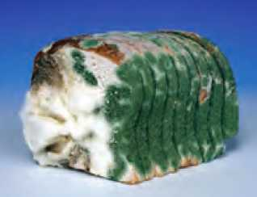

Lesson adapted from *Growing, Growing, Growing Exponential Relationships*, Connected Mathematics 2, Pearson, 2009.