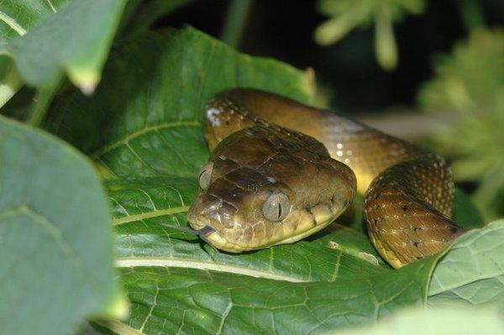**From Geometric Sequences to Tables and Graphs**

The geometric sequence from the Brown Tree Snake problem (1, 5, 25, 125, 625 . . .) can be written in the form of a table, as shown below:

**Year** 0 1 2 3 4

**# of Snakes** 1 5 25 125 625

The Brown Tree Snake was first introduced to Guam in year 0. At the end of year 1, five snakes were found; at the end of year 2, twenty-five snakes were discovered, and so on. Since we now have a table of the information, a graph can be drawn, where the year is the independent variable (x) and the number of snakes is the dependent variable (y). See below:

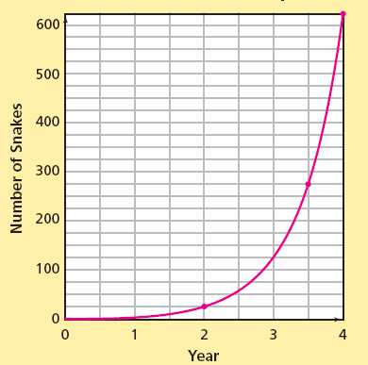

Notice that the graph of the table is not a straight line. Therefore, the graph is not linear in nature, which we already from the fact that the sequence is not arithmetic. Rather, the graph is curved and moves in a growing fashion very rapidly due to the fact that the common ratio *r* of this sequence is 5. The curved graph of this problem situation is known as an **exponential growth** function. An exponential growth function occurs when the common ratio *r* is greater than one. Tables and graphs make viewing the data from the problem situation easier to see and we can easily see from either the table or graph that in year 3, the snake population is 125.

Let us look at a similar population growth for a certain kind of lizard in both a table and graph. Use either one or both to answer the questions below.

C:\Documents and Settings\kkelly3\Local Settings\Temporary Internet Files\Content.IE5\EXBPP5VV\MC900346945[1].wmf

**Year**  0 1 2 3 4 5

**Number of lizards** 10 20 40 80 160 320

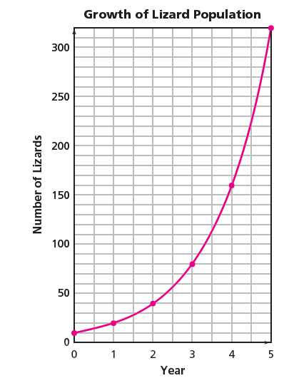Notice from the shape of the graph that the information is exponential in nature.

1. What information does the point (2, 40) on the graph tell you?
2. What information does the point (1, 20) on the graph tell you?
3. When will the population exceed 100 lizards?
4. Explain how to find the common ratio, using either the table or graph.
5. If the information from the table were written as a sequence, what is the initial term?
6. How could we find the 10th term in the table, graph, or sequence?

Discuss your answers with your group or with a partner. Now let us explore some more problems.

**The Mice Problem**

A population of mice has a growth factor (otherwise known as the common ratio) of 3. After 1 month, there are 36 mice. After 2 months, there are 108 mice.

1. How many mice were in the population initially (at 0 months)? Explain how you found this number.
2. Write a sequence to show how the mice population is growing.
3. Is this sequence arithmetic or geometric? Explain how you know.
4. Now, put your sequence into the table below.

**Months**  0 1 2 3

**Number of Mice**

1. Is the graph of the table going to be a straight line or a curve? Explain your answer.
2. [](http://www.google.com/imgres?imgurl=http://jamesrahn.com/graph%20paper/graph_18.gif&imgrefurl=http://biodolaters.sosblogs.com/The-first-blog-b1/Graph-paper-1st-quadrant-only-b1-p29.htm&h=596&w=467&sz=10&tbnid=Ga3NlvkuP4ETlM:&tbnh=97&tbnw=76&zoom=1&docid=KsAAC60qbxDp8M&sa=X&ei=oUq1T_XqMYqo8AT2nPkP&ved=0CFoQ9QEwAQ&dur=6812)Graph the table to make sure of your answer on the graph below. Make sure you label and title the graph below.
   1. What is your scale for the x-axis?
   2. What is your scale for the y-axis?

[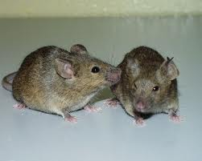](http://www.google.com/imgres?imgurl=http://1.bp.blogspot.com/_XQqmrnb_AiI/TLiXzdQNBLI/AAAAAAAAFUM/4PqwZP-rBec/s1600/two_mice_photo.jpg&imgrefurl=http://rolltideennisfamily.blogspot.com/2010_10_01_archive.html&h=308&w=385&sz=28&tbnid=RG0ln-Uf6vVvGM:&tbnh=102&tbnw=128&zoom=1&docid=cPisZGzJlsMnlM&sa=X&ei=FEu1T4-4MYiY8gSv-Pn5Dw&ved=0CGAQ9QEwAQ&dur=7640)

**[](http://www.google.com/imgres?imgurl=http://www.clker.com/cliparts/b/7/f/0/1194985422676876798ladybug_01.svg.med.png&imgrefurl=http://www.clker.com/clipart-3331.html&h=298&w=285&sz=30&tbnid=dEBByA4e89bJQM:&tbnh=86&tbnw=82&zoom=1&docid=WEK_8vVzzEvfiM&hl=en&sa=X&ei=gky1T-v6JIuE8AS5nMT8Dw&ved=0CIIBEPUBMBA&dur=234)The Ladybug Invasion**

As a biology project, Tamara is studying the growth of a ladybug population. She starts her experiment with 5 ladybugs. The next month she counts 15 ladybugs.

1. Suppose the ladybug population is growing arithmetically. How many beetles can Tamara expect to find after 2, 3, and 4 months? Write the sequence.
2. What is the common difference?
3. Now put the sequence into a table in the space below.
4. How long will it take the ladybug population to reach 200 if it is growing linearly?
5. Suppose the ladybug population is growing exponentially. How many beetles can Tamara expect to find after 2, 3, and 4 months? Write the sequence.
6. What is the common ratio?
7. Now put the sequence into a table in the space below.
8. How long will it take the ladybug population to reach 200 if it is growing exponentially?
9. Graph both tables on the designated graphs below. Be sure to label your axes.
10. Why does it take the ladybug population longer to reach 200 when it grows linearly?

**[](http://www.google.com/imgres?imgurl=http://jamesrahn.com/graph%20paper/graph_18.gif&imgrefurl=http://biodolaters.sosblogs.com/The-first-blog-b1/Graph-paper-1st-quadrant-only-b1-p29.htm&h=596&w=467&sz=10&tbnid=Ga3NlvkuP4ETlM:&tbnh=97&tbnw=76&zoom=1&docid=KsAAC60qbxDp8M&sa=X&ei=oUq1T_XqMYqo8AT2nPkP&ved=0CFoQ9QEwAQ&dur=6812)Linear Growth**  **Exponential Growth**

Adapted from *Growing,* *Growing, Growing, Exponential Relationships*, Connected Mathematics 2, Pearson, 2009.