Independent Practice with Sequences
For a sequence, write arithmetic and the common difference or geometric and the common ratio. If a sequence is neither arithmetic nor geometric, write neither.
- 2, 6, 18, 54, 162, ... _____________________ common __________ = ____

- 14, 34, 54, 74, 94, ... _____________________ common __________ = ____

- 4, 16, 36, 64, 100, ... _____________________ common __________ = ____

- 9, 109, 209, 309, 409, ... _____________________ common __________ = ____

- 1, 3, 9, 27, 81, ... _____________________ common __________ = ____

Given the initial term and either common difference or common ratio, write the first 6 terms of the sequence.

- a₁ = 7, r = 2 _________________________________________________

- a₁ = 7, d = 2 _________________________________________________

- a₁ = 3, r = 5 _________________________________________________

- a₁ = 4, d = 15 _________________________________________________
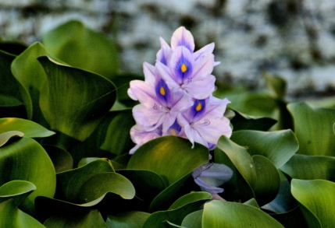
The water hyacinth is an invasive species from Brazil, which has found its way into North Carolina in the north and inland of the Tar and Neuse river areas. Unchecked, the water hyacinth can lead to clogged waterways, altered water temperature and chemistry, and the exclusion of native plants and wildlife in our own state. Some NC biologists found a region in which 76.9 miles² were covered by the water hyacinth. They decided to monitor the area by checking it again every 10 days. Here’s the data that they collected:
76.9; 157.8; 315.6; 631.2; 1,262.4, . . .
- Is the area of the plant growing arithmetically or exponentially? Explain how you know by listing the features of the sequence (common difference or common ratio).

- How is this problem different from the Brown Tree Snake sequence?

