Interpretations of Graphs - Homework

Sunflower Seed Graphs
Ian and his friends were sitting on a deck and eating sunflower seeds. Each person had a bowl with the same amount of seeds. The graphs below all show the amount of sunflower seeds remaining in the person’s bowl over a period of time.

Write sentences that describe what may have happened for each person.
a) | b) | c) | d)
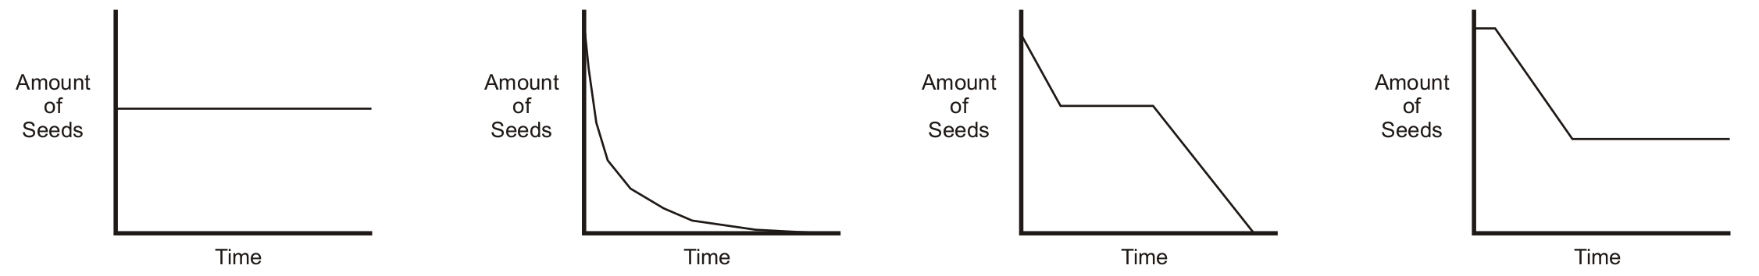

Multiple Choice
Indicate which graph matches the statement. Give reasons for your answer.
1. A bicycle valve’s distance from the ground as a boy rides at a constant speed.
a) | b) | c) | d)
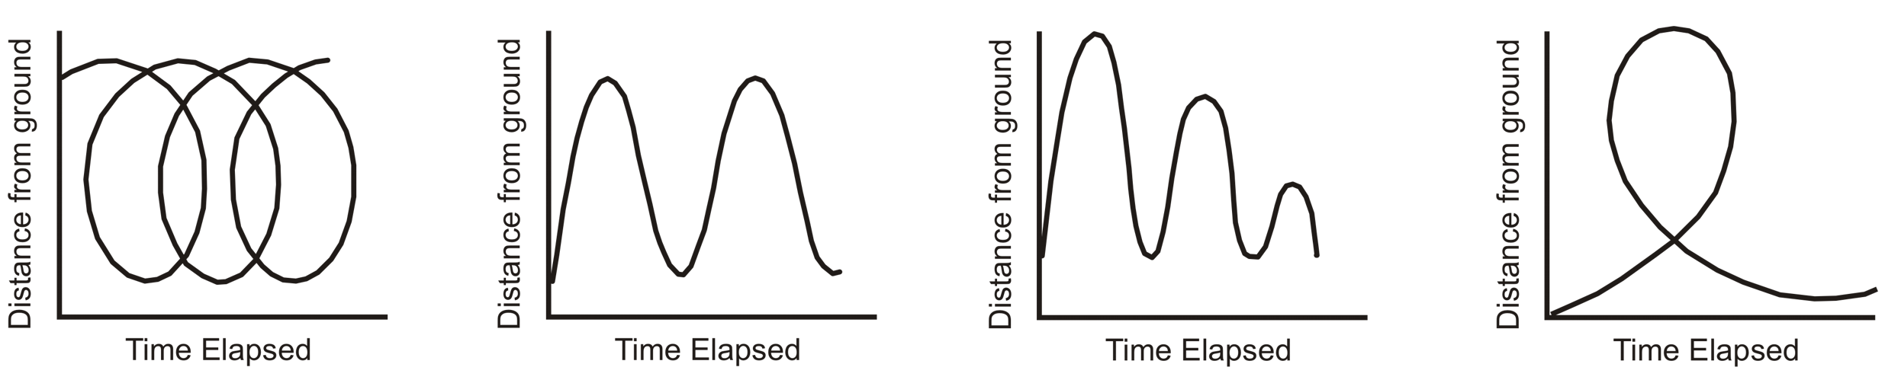

2. A child swings on a swing, as a parent watches from the front of the swing.
