THINK ABOUT THE SITUATION

Pay for Selling Credit Card Customers
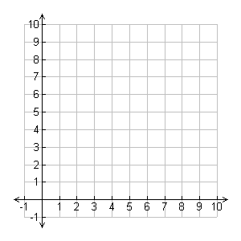
Daily Pay (in dollars)
Number of Applications
0
20
40
60
80

100
0 4 8 12 16 20

Think about the connections among graphs, data patterns, function rules, and problem conditions for linear relationships.
a) How does Barry’s daily pay change as the number of applications he collects increase? How is that pattern
of change shown in the graph?

b) If the linear pattern shown by the graph holds for other (number of applications, daily pay) pairs, how much
would you expect Barry to earn for a day during which he collects just 1 application? For a day he collects
13 applications? For a day he collects 25 applications?

c) What information from the graph might you use to write a rule showing how to calculate daily pay for any
number of applications?

