Graphical Stories

Below the following graphs are three stories about walking from your locker to your class.

Two of the stories correspond to the graphs. Match the graphs and the stories. Write stories for the other two graphs. Draw a graph that matches the third story.

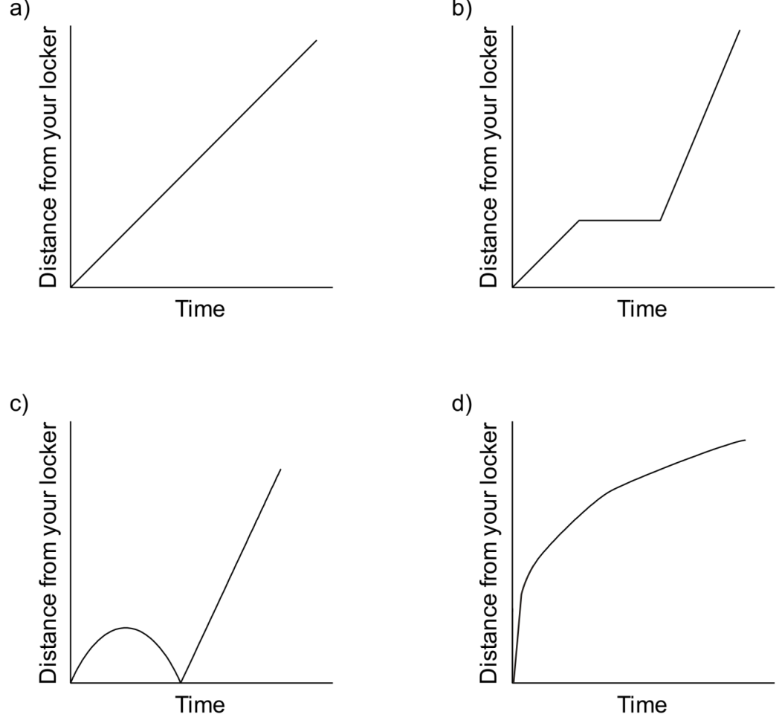

1. I started to walk to class, but I realized I had forgotten my notebook, so I went back to my locker and then I went quickly at a constant rate to class.

2. I was rushing to get to class when I realized I wasn’t really late, so I slowed down a bit.

3. I started walking at a steady, slow, constant rate to my class, and then, realizing I was late,
I ran the rest of the way at a steady, faster rate.

