Name: _______________________________________________________ Period: __________

Page 148 #1 – 13, 46, 47, 48

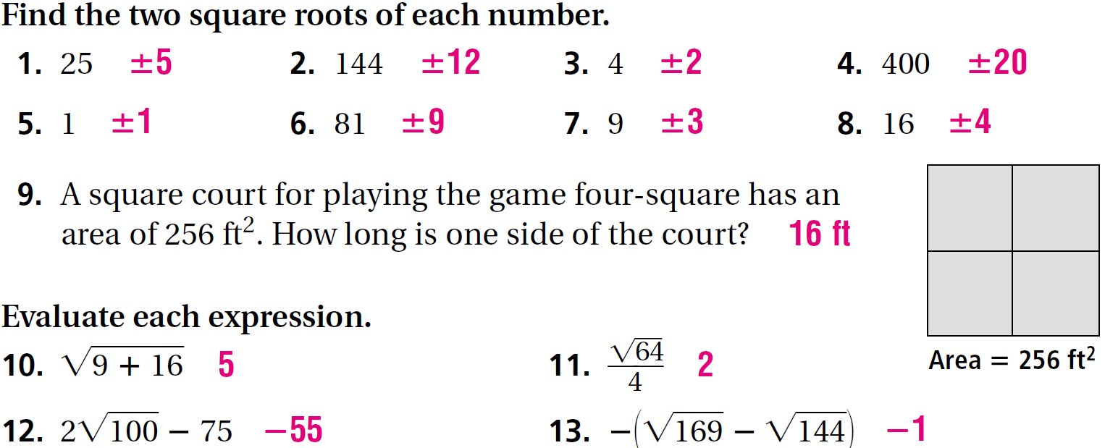

- A chessboard contains 32 black and 32 white squares. How many squares are along each side of the game board?

___________________________________________________________________________

- A carpenter wants to use as many of his 82 small wood squares as possible to make a large square inlaid box lid.
How many squares can the carpenter use? How many squares would he have left?

__________________________________, ________________________________________

How many more small wood squares would the carpenter need to make the next larger possible square box lid?

___________________________________________________________________________

- The square root of a number is five less than six times four. What is the number?

___________________________________________________________________________

