Algebraic Equation Graph

Table

Create the missing representations of the given linear function.

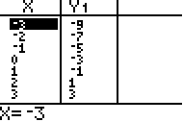

Algebraic Equation Graph

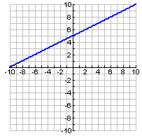

Table

Create the missing representations of the given linear function.

Algebraic Equation Graph



Table

Create the missing representations of the given linear function.

Algebraic Equation Graph

Table

Create the missing representations of the given linear function.

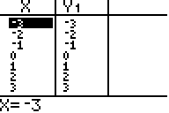

Algebraic Equation Graph

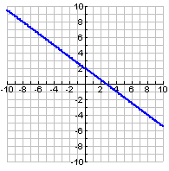

Table

Create the missing representations of the given linear function.

Algebraic Equation Graph



Table

Create the missing representations of the given linear function.

Algebraic Equation Graph

Table

Create the missing representations of the given linear function.

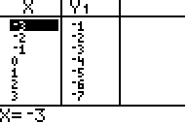

Algebraic Equation Graph

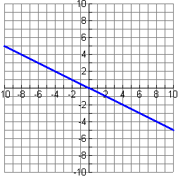

Table

Create the missing representations of the given linear function.

Algebraic Equation Graph



Table

Create the missing representations of the given linear function.

Algebraic Equation Graph

Table

Create the missing representations of the given linear function.

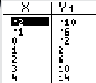

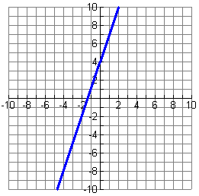Algebraic Equation Graph

Table

Create the missing representations of the given linear function.

Algebraic Equation Graph



Table

Create the missing representations of the given linear function.

Algebraic Equation Graph

Table

Create the missing representations of the given linear function.

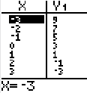

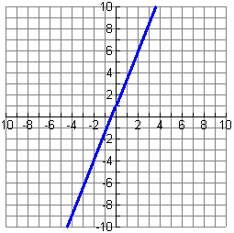Algebraic Equation Graph

Table

Create the missing representations of the given linear function.

Algebraic Equation Graph



Table

Create the missing representations of the given linear function.