 | Problem 1 | Problem 2 | Gridded Response
Monday | A 13-foot ladder leans against a building. The ladder reaches the building 12 feet above the ground. How far is the base of the ladder from the wall? | Describe the graph from  x = -1 and x =1 as linear, non-linear, increasing, decreasing. | Problem 1  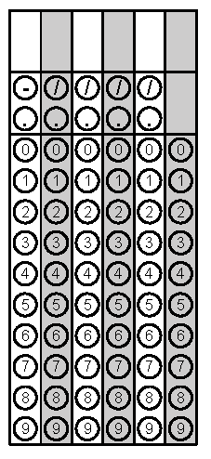
Tuesday | Write the equation of a line that passes through the origin and the point (-4,5) | What is the value of the expression  $$\frac{64,000,000}{3.2×{10}^{3}}$$ | Problem 2
Wednesday | What is the negative solution to the equation  $$x^{2}+4=29?$$ | Circle the irrational values.  $$0.12123123412345…$$  $$0.\overline{12}$$  $$\sqrt{2}∙\sqrt{8}$$  $$\frac{7π}{3π}$$ | Problem 1
Thursday | In the diagram, line r is parallel to line s. Find the measure of angle 3. | Solve for x.  8x+4(4x− 3)= 4(6x+ 4)− 4 | Problem 1
Friday | What is the slope of the line that passes through the points (-5, 3) and (-5, 8)? | Paisley can send 5 texts per minute. The table below shows how fast Zinn can text. What is the difference between their texting rates? | Problem 2

