 | Problem 1 | Problem 2 | Gridded Response
Monday | Solve for x.  $$-2\left(3x-5\right)+4x=-3x-5+x$$ | A builder needs to add diagonal braces to a wall. The wall is 18 feet by 24 feet. How long is each brace? | Problem 2  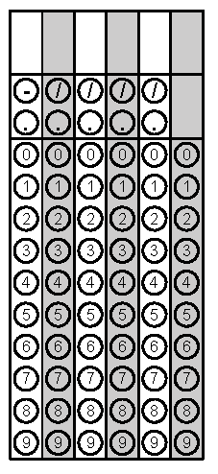
Tuesday | Simplify  $$0.2\overline{3}∙3\frac{2}{3}$$ | In the figure below, lines K and C are parallel and lines A and J are parallel.  Explain why angle 8 and angle 15 are congruent. | Problem 1
Wednesday | Josh is saving for a new video game. The game he wants to buy is 46 dollars. Josh has 25 dollars saved from his birthday. Josh decides he will quit eating extra snacks at lunch to save money. If Josh saves 75 cents every day, how many school days will it be before Josh can buy the video game? | The area of a square is 76 square inches. Is the length of each side a rational or irrational value? | Problem 1
Thursday | One of the congruent angles of an isosceles triangle measures 42°. Find the measures of the other two angles. | Simplify  $$-3\sqrt{\frac{4}{9}}+ \sqrt{52-16}$$ | Problem 2
Friday | A cone shaped tent has a height of 7.5 feet and a diameter of 12 feet. Find the volume of the cone. | Solve for y.  $$5x-3y=-27$$ | Problem 1

