 | Problem 1 | Problem 2 | Gridded Response
Monday | Solve for z.  $$\frac{2z-4}{-6}=23$$ | Circle the integers. If it is not an integer, explain why.  $$-\sqrt{17}$$  $$\frac{7π}{π}$$  $$\sqrt[3]{-216}$$  $$2.\overset{̿}{82}$$ | Problem 1  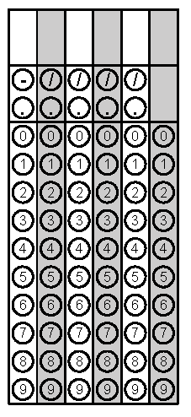
Tuesday | On a number line, Point X represents $-2\sqrt{36+64.}$ Point Y represents $\sqrt[3]{27}+10.$What is the distance between the two points? | In the figure below, lines m and n are parallel. The measure of angle 1 is 57º and the measure of angle 2 is 48º. Find the measure of angles 3, 4, and 5. | Problem 1
Wednesday | Allen wants to join a gym. Gym A charges a $50.00 membership fee and $10 per month. Gym B does not charge a membership fee, but charges $25.00 per month. If Allen plans to join the gym for 4 months during the winter, which gym should he choose? | Solve for x.  $$\frac{2}{5}\left(10x-15\right)=10x+10$$ | Problem 2
Thursday | Tommy works as an electrician. He charges $40.00 flat fee a service call and $32.50 for each hour of labor. Tommy was paid $170.00 for his last job. How many hours did Tommy work on his last job? | Simplify  $$\frac{2a{(3a^{3}b^{-2})}^{4}}{{(9ab)}^{2}}$$ | Problem 1
Friday | Sean bought 64 bags of dirt to completely fill a cube-shaped flower garden. Each bag fills one cubic foot in the flower garden. What is the length, in feet, of one of the sides of the flower garden? | Find the measures of each angle.  Measure of Angle A = _____  Measure of Angle B = _____  Measure of Angle C = _____ | Problem 1
Questions adapted from Score21 and SchoolNet

