 | Problem 1 | Problem 2 | Gridded Response
Monday | The largest elephant on record weighed 2.4 x 10⁴ pounds. If we put this elephant on a diet, he would lose 1 x 10² pounds per month, how much would the elephant weigh at the end of one year? | Find the product of the integers between $-\sqrt{20 }$and$-\sqrt{52}$. | Problem 2  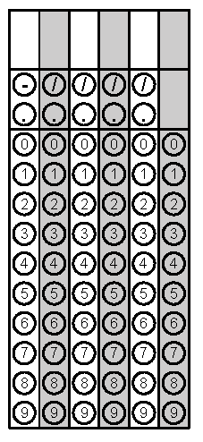
Tuesday | A square has an area of $\frac{49}{81} {inches}^{2}.$In inches, what is the length of each side of the square? | Order the following values from greatest to least.  $$\sqrt{7}$$  $$2.4$$  $$π$$  $$\frac{45}{15}$$ | Problem 1
Wednesday | Using the equation  $$\frac{7^{x}}{7^{y}}=\frac{1}{7^{3}}$$  find the value of x if y = 12. | Michael is shopping for cubic toy chests. One chest has a volume of 216 cubic feet. Another chest has a volume of 125 cubic feet. What is the difference in the side lengths of the two chests? | Problem 1
Thursday | Circle the irrational values.  $$\sqrt{\frac{1}{4}}$$  $$\sqrt{2}$$  $$\sqrt[3]{12}$$  $$0.1\overline{6}$$ | Find the value of  $$0.5\overline{6 }∙5\frac{5}{17}$$ | Problem 2
Friday | Find the value of x.  $$x^{3}=\frac{27}{216}$$ | A piece of construction paper has a thickness of  4.3 x 10⁻³ inches. A piece of cardstock has thickness of 5.2 x 10⁻³ inches. How tall is a stack of 10 sheets of construction paper and 15 sheets of cardstock? Write your answer in scientific notation. | Problem 1
http://animals.sandiegozoo.org/animals/elephant
Questions adapted from Score21 and SchoolNet

