 | Problem 1 | Problem 2 | Gridded Response
Tuesday | Suppose a dog can run 60 feet in 7 seconds. A cat can run 35 feet in 5 seconds. Which animal can run faster? How much faster? | Brandon purchased three cheeseburgers for $1.29 each and two milkshakes for $2.75 each. If sales tax is 10%, what is the total of Brandon’s purchase? Round to the nearest hundredth | Problem 2  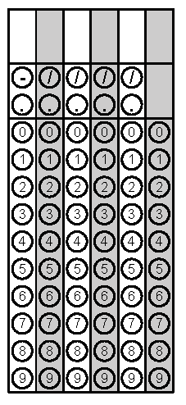
Wednesday | Below is the weight of the five football players from each team. How much higher is the median weight of the Panthers compared to the Steelers?  Panthers Steelers  Cam Newton 245 Ben Roethlisberger 240  Greg Olsen 253 DeAngelo Williams 207  Mike Tolbert 250 Antonio Brown 181  Michael Oher 315 Le’Veon Bell 225  Thomas Davis 235 Ryan Shazier 230 | Solve the equation.  $$8=-2x+16$$ | Problem 1
Thursday | Chris has 28 t-shirts. One fourth of the t-shirts are red, three-sevenths of the  t-shirts are blue; the remainder of the t-shirts are gray. How many gray t-shirts does he own? | What is the surface area of this figure?  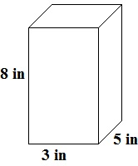 | Problem 2

Grading Warm-ups:
- Each box is worth one point (including grid-in response)
- You must show all work in the box and circle your final answer
- NO work = NO credit
- Mark an answer correct with a check mark
- Mark an answer wrong with an X
- Write the student’s score at the top of the paper # correct
Total

Gridded Response:
- ALIGN answers to the LEFT
- Convert all mixed #s to improper fractions

